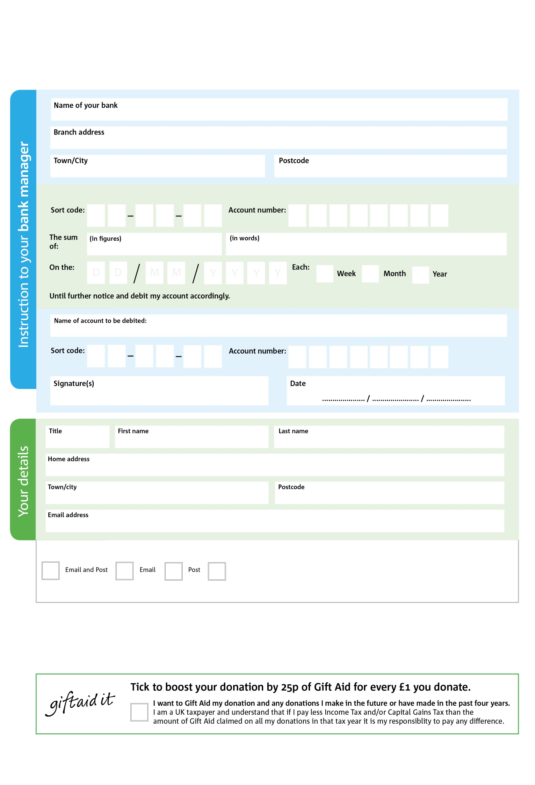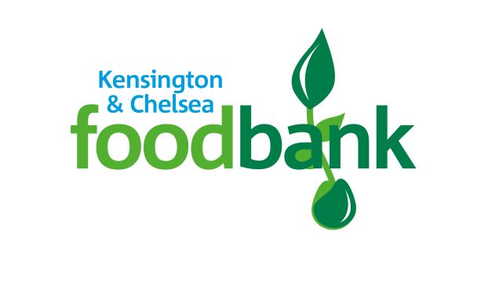

Please pay Kensington & Chelsea Foodbank

Reg. Charity No: 1193820 | Reg. in England & Wales

POSTAL ADDRESS: Kensington & Chelsea Foodbank, Notting Hill Methodist Church 240 Lancaster Road, London, W11 4AH



V



V



V



V



V



V



V

**Please pass a copy of this form to onto your named bank or building society.**

We would love to keep you up to date with information about Kensington & Chelsea Foodbank. Please tick your preference:

You can change your preferences any time by contacting us on 0203 728 9003 or emailing us at [info@kensingtonchelsea.fooodbank.org.uk](mailto:info@kensingtonchelsea.fooodbank.org.uk)

I do not wish to receive future communications from K & C Foodbank

**Data protection**

*'Kensington & Chelsea Foodbank is committed to protecting your privacy and will process your personal data in accordance with current*

*Data Protection legislation. Kensington & Chelsea Foodbank collects information to keep in touch with you and supply you with information relating to our work. To unsubscribe from our newsletter, send a message to the email address above with the word unsubscribe in the subject line. A full data privacy statement for financial donors is available from the foodbank on request.’*

**Standing Order Mandate**

**kensingtonchelsea.foodbank.org.uk**

You can change your preferences any time by contacting us on XXXXXXXXXXX or emailing us at XXXX@XXXXXXXXXX.foodbank.org.uk

I do not wish to receive future communications from XXXXXX Foodbank